**Codework Digital**

**Team members:**

Chanse Stephens

Cat Schnelle

Elijah Pemberton

Kevin Sims

**Group # 4**

**Course:** CSCI441-VA

**Github**: <https://github.com/CSchnelle/Codework-Digital>

theTalkMadeSimple.com

March 24, 2020

# Product Overview

TheTalkMadeSimple.com is a desktop and mobile electronic course website. This project is designed to create a basic template shell for our client to easily upload media content for users. This webpage will host a curriculum created by our client in order to support parental discourse with their children for important life topics.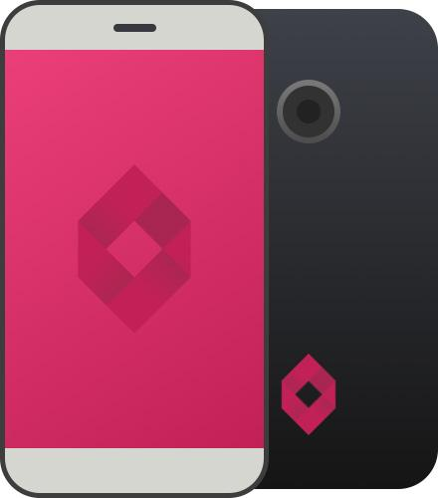

## Features

The website includes a landing page with free content for any visitor, a secure sales page where users can pay for premium content, an account creation and login feature that will only capture email addresses and allow users to purchase premium content and give their accounts access. This site also includes visitor tracking using Google Analytics.

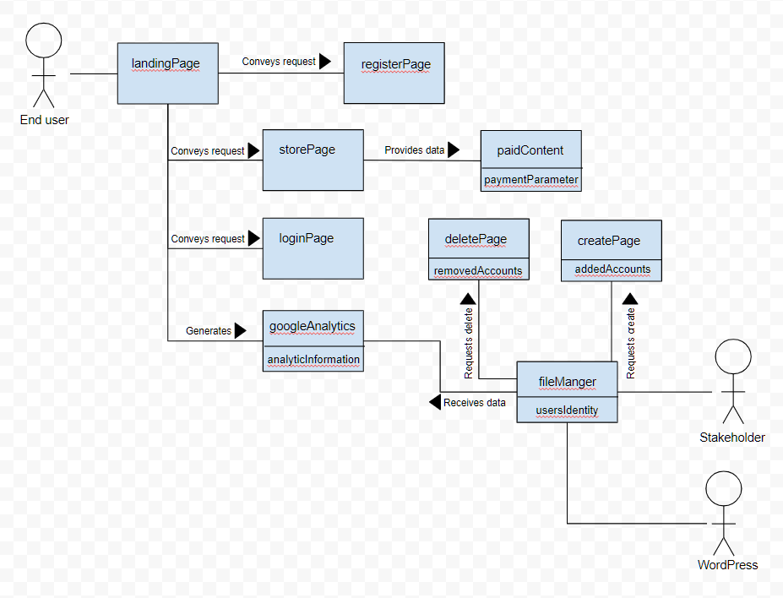

### System Diagram

This diagram shows the basic site features and their relationships.

## Design

Using a purposeful layout with a simple interface that is easy to navigate and a strategic use of color, TheTalkMadeSimple is a responsive educational platform that will keep users engaged.

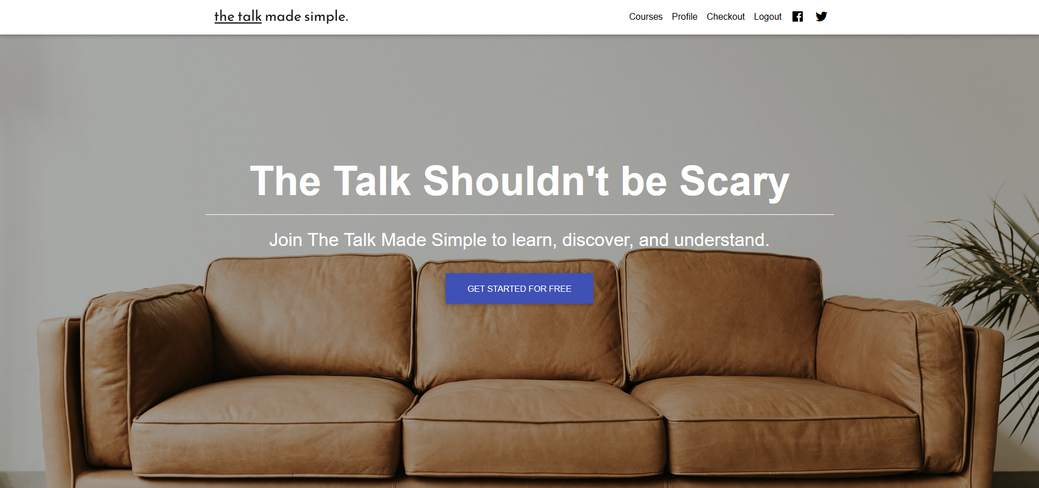

# How to

This website will be hosted by WordPress and will be accessible via a browser on any desktop or mobile devices with internet access.